 | EUROPEAN COMMISSION  DIRECTORATE-GENERAL  INFORMATICS  Information Systems Directorate

European Commission
CIPADMIN Use Case Specification:
UC0080 - e-TrustEx Admin Console - Manage Users

Date: | 20/01/201715/09/2014
Version: | 21.000400
Authors: | Anamaria BATRINU
Revised by: | Sandro D'ORAZIO, Olivier DERVEAU, Maarten DANIELS
Approved by:
Public:
Reference Number:
TABLE OF CONTENTS
1. Use-Case Description 7
1.1. Primary Actor 7
1.2. Definitions, Acronyms and Abbreviations 8
1.3. Functional features list 8
1.4. References 8
1.5. Context Diagram 9
1.5.1. CIPA Administration Console 9
1.5.2. Configure Users module 10
2. Flow of events 10
2.1. Basic Creation flow 10
2.1.1. User chooses to create a new User 10
2.1.2. System displays the "Configure User" page 11
2.1.3. User enters information 11
2.1.4. System creates the User 13
2.1.5. User acknowledges the creation 13
2.1.6. System shows the configuration in View mode 13
2.1.7. The basic creation flow ends. 14
2.2. Basic search flow 14
2.2.1. User chooses to search for users 14
2.2.2. System displays the "Search User" page 14
2.2.3. User enters the search criteria 14
2.2.4. The System searches the users 14
2.2.5. System displays the users found 15
2.2.6. User views the result list 15
2.2.7. The basic search flow ends. 15
2.3. Basic Visualization Flow 15
2.3.1. At 2.2.6, User selects a user from the list 15
2.3.2. System opens the user visualization 15
2.3.3. User visualises the details of the user: 16
2.3.4. Visualization flow ends. 16
2.4. Basic Modification Flow 16
2.4.1. At 2.3.3., User chooses to modify a user configuration 16
2.4.2. System opens the User Configuration page in edit mode 16
2.4.3. User makes the changes 18
2.4.4. System saves the modified User Configurations 18
2.4.5. User acknowledges the modification 19
2.4.6. System redisplays the user configurations page in view mode 19
2.4.7. The Modification flow ends. 19
2.5. Basic Deletion Flow 19
2.5.1. At 2.3.3., User chooses to delete a User configuration 19
2.5.2. System asks for deletion confirmation 19
2.5.3. User confirms the deletion 19
2.5.4. System deletes the User configuration 19
2.5.5. User acknowledges the deletion 20
2.5.6. The Deletion Flow ends. 20
2.6. Change Own Password 20
2.6.1. User wants to change password 20
2.6.2. System opens the Change Password page 20
2.6.3. User fills in the data 20
2.6.4. System saves the new password 20
2.6.5. User acknowledges the operation success 21
2.6.6. System redirects User to Home page 21
2.6.7. The Change Password flow ends. 21
2.7. Alternative Flows 21
2.7.1. A1: at steps 2.1.4(creation), 2.2.4(search) or 2.4.4(modification) Business Rules are not verified 21
2.7.2. A2: at step 2.2.4, no user configuration found for the specified criteria 21
2.7.3. A3: at steps 2.1.3., 2.6.3. User chooses Cancel option 21
2.7.4. A4: at step 2.1.3, User chooses Clear option 22
2.7.5. A5: at steps 2.1.3 and 2.4.3, User chooses to search for a Party 22
2.8. Exceptional Flows 22
2.8.1. E1: at steps 2.1.1, 2.2.1, 2.4.1 and 2.5.1 user is not authorized for the operation 22
3. Special Requirements 22
3.1. Interface(s) with other Systems 22
3.2. Security Requirements 22
3.3. Other Special Requirement 22
4. Preconditions 22
5. Post conditions 22
6. Additional Information 22
6.1. Includes 22
6.2. Extends 23
7. Mock-up screens 23
7.1. "Configure New User" page 23
7.2. "Search User" page 24
7.3. "View User Configuration" page 24
7.4. "Configure Existing User" page 24
7.5. "Delete User" page 25
7.6. "Change Password" page 25

Document History

Version | Date | Comment | Modified Pages
0.001 | 08/10/2013 | First draft | All
0.002 | 31/01/2014 | Updated functionality and mockups | All
0.003 | 10/04/2014 | Changes mostly related to using consistency regarding mockup buttons and their functionality. Updated Search business rules. Button labels renamed. Added screen showing partial deletion of user rights. Business rules renumbering. | Where needed
0.004 | 19/05/2014 | The part of the screen adding/editing a new/existing configuration has been redesigned. | Sections 7.1 and 7.4
0.005 | 10/06/2014 | Added new business rules (max field length, leading and trailing space trimming, one mandatory search field). Business rules renumbering. | Sections 2.1, 2.2 and 2.4
0.006 | 21/08/2014 | Clear button action detailed | Section 2.6.4
0.007 | 15/09/2014 | Added minimum field length of 2 characters. | Section 2.1
0.008 | 14/10/2014 | Maximum field length has been changed from 250 to 255 characters.
0.009 | 15/10/2014 | Removed specific messages (quoted ones) to allow more flexibility.
1.000 | 28/10/2014 | Modifications done to take into account multiple CBO users per domain(CIPADMIN-207) | Where needed
1.001 | 30/10/2014 | 1. Update of the mockups labels (CIPADMIN-243)  2. Updated business rules for passwords. Introduced opensource version specificity. | 1. Section 8  2. Sections 3.1 and 3.4
1.002 | 04/11/2014 | CIPADMIN-279 (logging) | Where needed
1.003 | 27/11/2014 | CIPADMIN-282 (disallow multiple role per business domain per user)  CIPADMIN-267 (support role) | Where needed
1.1 | 14/01/2015 | CIPADMIN-256 (user edit): added UC80_BR46 and UC80_BR47. | Sections 2.4 and 2.5
1.2 | 14/01/2015 | CIPADMIN-255 (change password option) | Sections 2.6 and 7.6
1.3 | 26/01/2015 | CIPADMIN-264
1.4 | 21/05/2015 | CIPADMIN-178: Password strength | Sections: Basic Creation flow, Basic Modification Flow, Change Own Password
1.5 | 29/07/2015 | JIRA ETRUSTEX-1520: displaying password guidelines in the password sections, instead of validating and showing warning at saving time. | Screens & sections mentioned in v.1.4
1.6 | 26/10/2016 | ETRUSTEX-1392
2.0 | 20/01/2017 | ETRUSTEX-1937: Reorganizing CIPAdmin user roles

Use-Case Description

The system must allow the configuration of the different business roles: General Administrator, Central Business Owner, Local Business Owner and Support.
This use case depicts the sequence of actions that a user needs in order to configure another user for accessing the administration console and its features. The document also describes the management actions that correspond to a created user, such as Update, Delete, View and Search.
There are two types of users who will be able to access the feature: a General Administrator (referred to as ADM), and a Central Business Owner (referred to as CBO). A user having Support role has access to search and visualize features of the configured users.
The "Configure User" feature is exposed on the CIPAdmin module of e-Trustex platform.
In the remainder of the document the CIPADMIN application will be referred to as the System.

Primary Actor
A human user can access the Manage Users feature via CIPAdmin interface. For detailed user access rights on each feature option, please see UC 0100 - eTrustEx Admin Console - Authenticate and Authorise User, section 6.3 User Access Rights.
In the remainder of the document, the user will be referred to as User or by his/her role, in those cases where role specific rules apply.

Definitions, Acronyms and Abbreviations
Acronym, Abbreviation or Definition | Explanation
CIPA | Common Infrastructure for Public Administrations
CIPADMIN | CIPA AdminConsole
ADM | A user having General Administrator role. The General Administrator is the Administrator of the CIPAdmin application. ADM can do everything a Central or Local Business Owner can do, plus complete user configuration, profile, document, role, transaction and domain management.
CBO | A user having Central Business Owner role. The Central Business Owner is responsible for the organization and operation of a business and uses CIPA in his business context.
UC(s) | Use Case(s)

  - References
Ref. | Reference | Title / description | Version | Date
[R1] | CIPADMIN-VISION | CIPADMIN Vision document | V.61-EN | 18/04/2013

Context Diagram

CIPA Administration Console
The diagram below depicts all the Services available on the CIPA Administration Console for e-TrustEx platform. Depending on the user role, only a subset of those services is exposed on the e-TrustEx Administration Console home page.
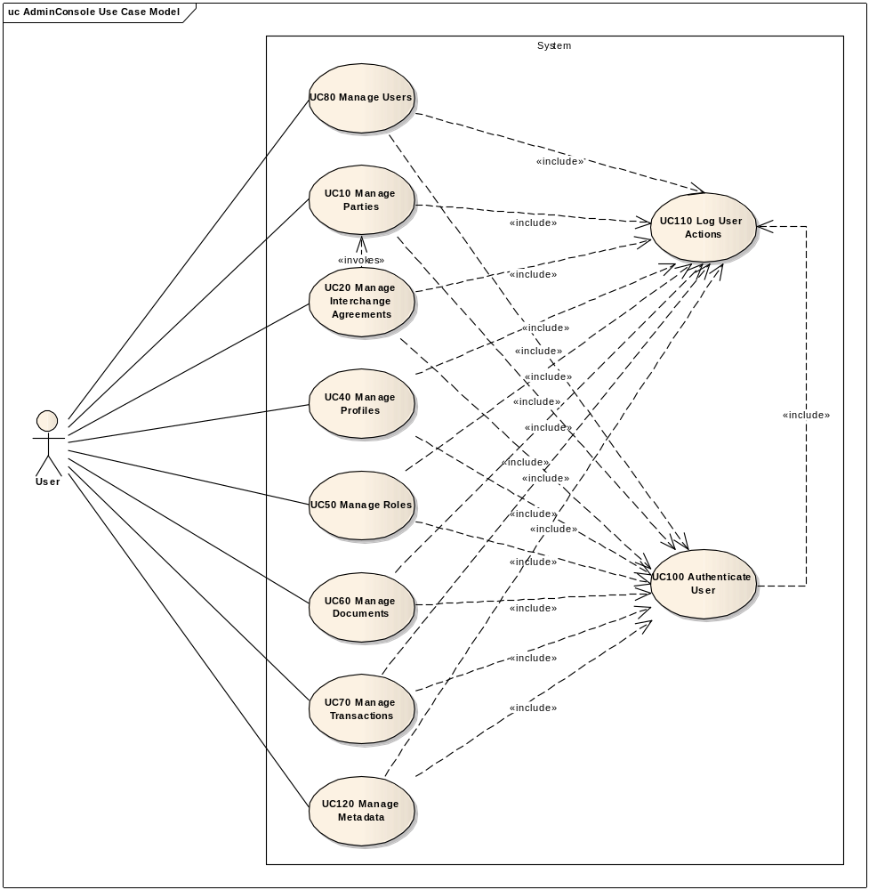

Configure Users module
The diagram below depicts how this use case interacts with other use cases implemented in the Administration Console.
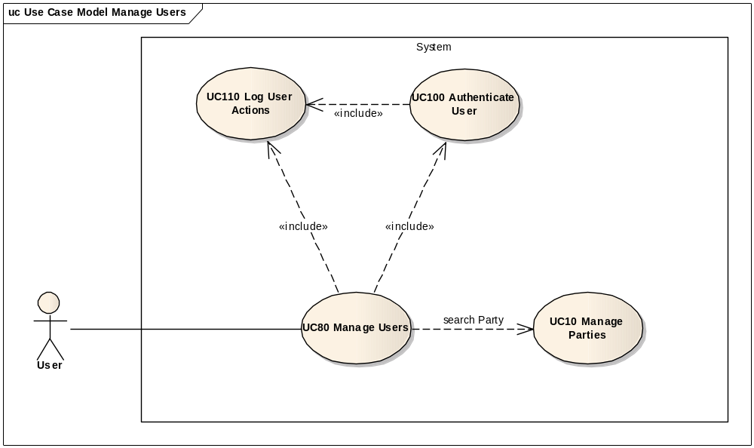

Flow of events
The conventions described in User Interface Generic Conventions document must be applied.

Basic Creation flow
ID | Description
UC80_BR01 | User needs to have the correct access rights in order to access this feature. Please see UC 0100 - eTrustEx Admin Console - Authenticate and Authorise User, section 6.3 User Access Rights for more information.
User navigates the menu: Business Configuration > CIPAdmin Users > Create.

User chooses to create a new User
ID | Description
UC80_BR02 | For CBO, the selected user role is defaulted to LBO CBO and not modifiable.
UC80_BR03 | For CBO, the selected business domain is defaulted to their business domain and not modifiable.
UC80_BR04 | CBO and ADM are is allowed to create multiple user configurations.
UC80_BR05 | Not specifying a business domain when configuring a user with ADM role means the user will have ADM role for all business domains.
UC80_BR06 | ADM User is allowed to configure users for the business domains he/she is configured with.
UC80_BR53 | If and ADM user with limited rights configures a new ADM user by not specifying a business domain, than the new ADM user shall not have access to other business domains than the ones of the ADM user that created his/her configuration.  By ADM user with limited rights, we understand and ADM user that doesn't have access rights on all eTrustEx defined business domains.

System displays the "Configure User" page
The System displays the Configure User page as described in paragraph 7.1. "Configure New User" page:
- System retrieves all available user roles and populates the user role list with the roles the user is allowed to use
- System retrieves all available business domains and populates the business domain list with the business domains the user is allowed to use
- User role and business domain lists are ordered in ascendant alphabetical order and ignoring case.

User enters information
- User specifies the username. If opensource version, password and confirm password need also to be specified.
- ADM specifies the user role
- ADM specifies the business domain if at step (2) the specified user role is not ADM
- ADM specifies the party if at step (2) the specified user role is LBO. CBO always specifies a party. The party must pertain to the business domain specified at step (3).
- User can add a new user configuration:
  - – User adds a new configuration
  - – System validates the specified configuration
ID | Description
UC80_BR07 | User role is mandatory.
UC80_BR08 | The business domain is mandatory if selected user role is not ADM.
UC80_BR09 | The party is mandatory if selected user role is LBO, and must pertain to the chosen business domain.
UC80_BR10 | User must be authorized to configure users for the specified business domain.
UC80_BR12 | The configuration must be unique: no configuration having the same user role, business domain and party is allowed (per user).
UC80_BR52 | Openversion only:  It is recommended that the passwords fields follow the below guidelines:  - Length: minimum length of 10 characters  - Complexity – minimum 3 of the following:  - At least one lowercase alphabetic character (a-z)  - At least one uppercase alphabetic character (A-Z)  - At least one digit (0-9)  - At least one special character  These guidelines are displayed as information at the top of Credentials Section in the screen.  This business rule has informative purpose and does not impose the password recommendations to the user, thus the system being able to save the record even if the user does not follow the guidelines.
  - – System updates the configuration list. Note that user access rights shall be ordered by user role in ascendant alphabetical order and ignoring case.
  - restart from step (2)
- User chooses the save option.

System creates the User
ID | Description
UC80_BR13 | Username is mandatory.
UC80_BR39 | Openversion only: "Password" and "Confirm password" are mandatory.
UC80_BR40 | The "Password" and "Confirm password" fields must contain the same value. If not, user is notified about the mismatching passwords.
UC80_BR07 | User role is mandatory.
UC80_BR14 | For CBO, selected user role shall always be LBO CBO.  If a CBO wants to create another CBO user for his/her business domain, then he/she needs to send a request to DIGIT-CIPA-SUPPORT@ec.europa.eu.
UC80_BR08 | The business domain is mandatory if selected user role is not ADM.
UC80_BR09 | The party is mandatory if selected user role is LBO, and must pertain to the chosen business domain.
UC80_BR15 | There shall be at least one configuration defined. This configuration shall respect rules UC80_BR07, UC80_BR14, UC80_BR08, UC80_BR09.
UC80_BR16 | Username shall be unique.
UC80_BR17 | Username and password fields must be at most 255 characters long.
UC80_BR18 | Username and password fields must be at least 2 characters long.
UC80_BR19 | Leading and trailing spaces must not be part of the save field nor taken into account for UC80_BR17 and UC80_BR18, for username field.
UC80_BR43 | A user can have only one configuration per business domain.  E.g. There shall be no user having ADM and CBO role for the same business domain.
UC80_BR54 | An user having ADM rights on all business domain shall not be given an extra configuration with restrictive rights on a specific business domain (he/she is already an ADM user on that business domain which will contradict UC80_BR43)

- The System validates the page according to the business rules.
- The System saves the User and its configurations (if a password is provided, it is hashed and saved base64 encoded).
- System logs the successful creation of the user and of each user configuration: include use case Log CIPAdmin User Actions
- The System notifies the user of the success of the operation

User acknowledges the creation

System shows the configuration in View mode
- System reloads data in view mode (see 2.3. Basic Visualization Flow)
- User can now review the configuration

The basic creation flow ends.

Basic search flow
ID | Description
UC80_BR01 | User needs to have the correct access rights in order to access this feature. Please see UC 0100 - eTrustEx Admin Console - Authenticate and Authorise User, section 6.3 User Access Rights for more information.

User chooses to search for users
User navigates the menu: Business Configuration > CIPAdmin Users > Search.

System displays the "Search User" page
System displays the search page as described in paragraph 7.2. "Search User" page. User role, business domain and party lists are ordered in ascendant alphabetical order and ignoring case.
ID | Description
UC80_BR20 | For CBO, the search will consider only the users that are having CBO or LBO user role and pertain to the business domain of the CBO:  - User role options: All, CBO, ADM, where "All" means both CBO and LBO ADM roles (but not ADM roles)  - Business domain defaulted to CBO's business domain and not modifiable
UC80_BR44 | For SUP, the search will consider only the users pertaining to the business domain of the SUP user:  - Business domain defaulted to SUP's business domain and not modifiable

User enters the search criteria
- User enters one or more search criteria. A search criterion left empty means the concerned field will not be taken into account. The user can search by:
    - Username
    - User role
    - associated business domain (if ADM)
    - Associated party
- User chooses the search option.

The System searches the users
ID | Description
UC80_BR21 | A field left empty or containing only spaces is not taken into account during the search.
UC80_BR22 | For CBO:  - user role criteria shall always be one of the following: LBOADM, CBO or All, where "All" means both CBO and LBOADM roles (but not ADM roles)  - business domain criteria shall always be the CBO's business domain
UC80_BR45 | For SUP:  - business domain criteria shall always be the SUP's business domain
UC80_BR23 | Character case is ignored.
UC80_BR24 | Trailing and leading spaces are ignored.
UC80_BR25 | Field value can contain a partial match (except for the drop down lists).
UC80_BR26 | At least one search field needs to be filled in.
The system searches the users that satisfy all the entered criteria.

System displays the users found
The system displays the list of users corresponding to the search criteria, showing the following information:
  - Username
  - All user configurations consisting of:
    - User role
    - Business domain
    - Party
The results are ordered by username in ascendant alphabetical order and ignoring case.

User views the result list
- User can view the details of a user by clicking on its username in the list (see 2.3. Basic Visualization Flow)
- User can launch a new search

The basic search flow ends.

Basic Visualization Flow
ID | Description
UC80_BR01 | User needs to have the correct access rights in order to access this feature. Please see UC 0100 - eTrustEx Admin Console - Authenticate and Authorise User, section 6.3 User Access Rights for more information.

At 2.2.6, User selects a user from the list

System opens the user visualization
The system displays the user visualisation page as described in paragraph 7.3."View User Configuration" page.
- System reads the data
- System loads data on screen
- All fields are protected
- "Cancel", "Edit" and "Delete" buttons are made available.
  - If CBO visualizes another CBOADM, "Edit" and "Delete" buttons are protected, and a message on top of the page informs the CBO that user rights can be changed by sending a request to DIGIT-CIPA-SUPPORT@ec.europa.eu.
  - CBO can "Edit" and "Delete" other CBOs configured in his/her business domain.
  - If SUP, "Edit" and "Delete" buttons are protected.

User visualises the details of the user:
- User can return to the result list by choosing "Cancel", the view flow ends and basic search flow restarts at 2.2.6
- ADM or CBO can choose to edit or to delete a User (see 2.4 Basic Modification Flow and 2.5. Basic Deletion Flow). CBO can choose to edit or to delete only users having LBO CBO role.

Visualization flow ends.

Basic Modification Flow
ID | Description
UC80_BR01 | User needs to have the correct access rights in order to access this feature. Please see UC 0100 - eTrustEx Admin Console - Authenticate and Authorise User, section 6.3 User Access Rights for more information.

Note that a user having CBO role shall not be able to modify a user which is not configured as LBO CBO in his/her business domain, and when doing so he/she shall only be able to modify that particular configuration, leaving all other configurations in place.
If a CBO user wants to modify a user configured as CBO for his/her business domain in order to change the configuration having the CBO role, then he/she shall send a request to DIGIT-CIPA-SUPPORT@ec.europa.eu.

At 2.3.3., User chooses to modify a user configuration
In the visualization page, user chooses the modify option. CBO can choose this option only if the visualized user is another LBO CBO in the context of CBO's business domain.

System opens the User Configuration page in edit mode
System displays the user configuration page as in paragraph 7.4."Configure Existing User" page.
ID | Description
UC80_BR27 | Username is read-only.
UC80_BR17 | Username and password fields must be at most 255 characters long.
UC80_BR18 | Username and password fields must be at least 2 characters long.
UC80_BR19 | Leading and trailing spaces must not be part of the save field nor taken into account for UC80_BR17 and UC80_BR18, for username field.
UC80_BR41 | It is allowed to change the corresponding password of an existing user.
UC80_BR42 | By default, the password fields are not shown to the user. An option to change the password is made available to the user.
UC80_BR39 | Openversion only: "Password" and "Confirm password" are mandatory.
UC80_BR52 | Openversion only:  It is recommended that the passwords fields follow the below guidelines:  - Length: minimum length of 10 characters  - Complexity – minimum 3 of the following:  - At least one lowercase alphabetic character (a-z)  - At least one uppercase alphabetic character (A-Z)  - At least one digit (0-9)  - At least one special character  These guidelines are displayed as information at the top of Credentials Section in the screen.  This business rule has informative purpose and does not impose the password recommendations to the user, thus the system being able to save the record even if the user does not follow the guidelines.
UC80_BR40 | The "Password" and "Confirm password" fields must contain the same value. If not, user is notified about the mismatching passwords.
UC80_BR28 | ADM User can only modify user configurations for business domains they are authorized to use.
UC80_BR29 | CBO can only modify user configurations associated to his/her business domain and using LBO user role.
UC80_BR30 | When modifying a user configuration, the user role is read-only for CBO actors.
UC80_BR31 | When modifying a user configuration, the business domain is read-only for CBO actors.
UC80_BR32 | For each configuration, the user has the option to edit or delete it.
UC80_BR33 | ADM User can only delete configurations used for a business domain he/she is authorized for.
UC80_BR34 | Users having CBO roles are only authorized to delete user configurations associated to their business domain and using LBO CBO user role.
UC80_BR43 | A user can have only one configuration per business domain.  E.g. There shall be no user having ADM and CBO role for the same business domain.
UC80_BR35 | User can add a new configuration to the configured user, respecting the above business rules.
UC80_BR46 | User cannot modify his/her own user configuration.  However, user can send a modification request to DIGIT-CIPA-SUPPORT@ec.europa.eu containing the details to modify and the reason. Note that user can change his/her own password via User / Change password menu option.
"Cancel", "Reset" and "Save" options are present.
User role and business domain lists are ordered in ascendant alphabetical order and ignoring case.
User access rights are ordered by user role in ascendant alphabetical order and ignoring case.

User makes the changes
- User makes the desired changes
- User chooses the save option

System saves the modified User Configurations
ID | Description
UC80_BR28 | ADM User can only modify user configurations for business domains they are authorized to use.
UC80_BR29 | CBO can only modify user configurations associated to his/her business domain and using LBO user role.
UC80_BR13 | Username is mandatory.
UC80_BR07 | User role is mandatory (for each added / modified user configuration).
UC80_BR02 | For CBO, the specified user role shall always be LBO CBO.
UC80_BR08 | The business domain is mandatory if the specified user role is not ADM.
UC80_BR09 | The party is mandatory if the specified user role is LBO, and must pertain to the chosen business domain.
UC80_BR10 | User must be authorized to configure users for the specified business domain.
UC80_BR12 | The configurations must be unique: no configuration having the same user role, business domain and party is allowed (per user).
UC80_BR43 | A user can have only one configuration per business domain.  E.g. There shall be no user having ADM and CBO role (or any other couple of roles) for the same business domain.
UC80_BR15 | There shall be at least one configuration defined per user.
UC80_BR46 | User cannot modify his/her own user configuration.  However, user can send a modification request to DIGIT-CIPA-SUPPORT@ec.europa.eu containing the details to modify and the reason. Note that user can change his/her own password via User / Change password menu option (opensource version).
- The system validates the page according to the business rules.
- The system saves the user configurations (if a password is provided, it is saved base64 encoded).
- System logs the successful modification of the user and of each user configuration that has been added, modified or deleted: include use case Log CIPAdmin User Actions
- The System notifies the User about the success of the operation

User acknowledges the modification

System redisplays the user configurations page in view mode
The system displays the user page in view mode as described in the chapter 7.3."View User Configurations" page.

The Modification flow ends.

Basic Deletion Flow
If a CBO user wants to delete a user configured as CBO for his/her business domain or to delete only this specific configuration, then he/she shall send a request to DIGIT-CIPA-SUPPORT@ec.europa.eu.

ID | Description
UC80_BR01 | User needs to have the correct access rights in order to access this feature. Please see UC 0100 - eTrustEx Admin Console - Authenticate and Authorise User, section 6.3 User Access Rights for more information.
UC80_BR38 | CBO can only delete users pertaining to their business domain and having only LBO CBO role in the context of CBO's this business domain. If the user is also configured with another business domain, or has also and ADM or CBO right, the CBO is not allowed to delete the user. Instead he/she can edit the user and remove the specific LBO CBO configuration pertaining to his domain if one exists.
UC80_BR47 | User cannot delete his/her own user configuration.  However, user can send a removal request to DIGIT-CIPA-SUPPORT@ec.europa.eu explaining the reason for deleting his/her account.

At 2.3.3., User chooses to delete a User configuration

System asks for deletion confirmation

User confirms the deletion
If user chooses to cancel the deletion, he is returned to the visualization page (step 2.3.3.).

System deletes the User configuration
- System verifies the business rules
- System deletes the user and his corresponding configurations
- System logs the successful deletion of the user and of his/her access rights configurations: include use case Log CIPAdmin User Actions
- System notifies user of the success of the operation

User acknowledges the deletion

The Deletion Flow ends.

Change Own Password
A user is not allowed to change his/her own user configuration, but can change his/her own password. This is mainly important for the opensource version of the application. For the internal version, even if a password is present, it will not be taken into account due to using ECAS authentication.
ID | Description
UC80_BR01 | User needs to have the correct access rights in order to access this feature. Please see UC 0100 - eTrustEx Admin Console - Authenticate and Authorise User, section 6.3 User Access Rights for more information.

User wants to change password
User chooses Business Configuration > CIPAdmin Users > Change Password.

System opens the Change Password page
System displays the change password page as in paragraph 7.6."Change Password" page.
The password guidelines are displayed in the screen.

User fills in the data
- User enters the old and the new password and repeats the new password
- User chooses the Save option

System saves the new password
ID | Description
UC80_BR48 | All fields are mandatory.
UC80_BR49 | Old password must match the current user password.
UC80_BR50 | New password and Confirm new password fields must have identical values.
UC80_BR52 | Openversion only:  It is recommended that the passwords fields follow the below guidelines:  - Length: minimum length of 10 characters  - Complexity – minimum 3 of the following:  - At least one lowercase alphabetic character (a-z)  - At least one uppercase alphabetic character (A-Z)  - At least one digit (0-9)  - At least one special character  These guidelines are displayed as information at the top of Credentials Section in the screen.  This business rule has informative purpose and does not impose the password recommendations to the user, thus the system being able to save the record even if the user does not follow the guidelines.
UC80_BR51 | The new password and the old password shall be different.
UC80_BR17* | Username and password fields must be at most 255 characters long.
UC80_BR18* | Username and password fields must be at least 2 characters long.
*Note that in this case rules UC80_BR17 and UC80_BR18 are applicable for the three passwords fields.
- The system validates the page according to the business rules.
- The system saves the new password hashed and base64 encoded.
- System logs the password change: include use case Log CIPAdmin User Actions
- The System notifies the User about the success of the operation

User acknowledges the operation success

System redirects User to Home page
The system displays the Home page of CIPAdmin.

The Change Password flow ends.

Alternative Flows

A1: at steps 2.1.4(creation), 2.2.4(search) or 2.4.4(modification) Business Rules are not verified
- System logs the error: include use case Log CIPAdmin User Actions
- The system notifies the user about the error
- Alternate flow ends and basic flow restarts at 2.1.3, 2.2.3 or 2.4.3.

A2: at step 2.2.4, no user configuration found for the specified criteria
- System logs the error: include use case Log CIPAdmin User Actions
- The system notifies the user that no user has been found
- Alternate flow ends and basic search flow restarts at 2.2.3

A3: at steps 2.1.3., 2.6.3. User chooses Cancel option
- System disregards all information provided by User
- System closes the page
- System redirects the user to CIPAdmin home page

A4: at step 2.1.3, User chooses Clear option
- Systems disregards all information provided by the user in the "New User Access Rights" section
- Alternate flow ends and basic creation flow restarts at 2.1.2.

A5: at steps 2.1.3 and 2.4.3, User chooses to search for a Party
- System opens a Party Search Popup: include section 2.2. Basic Search Flow (from step 2.2.2. System displays the "Search Party" page) of Manage Party Use Case.
- System fills in the read-only input text with the party name of the party selected at previous step
- Alternate flow ends and basic flow continues at 2.1.3, respectively 2.4.3.

Exceptional Flows

E1: at steps 2.1.1, 2.2.1, 2.4.1 and 2.5.1 user is not authorized for the operation
Include the steps in section 2.4.1 of Authenticate and Authorise User Use Case.

Special Requirements

Interface(s) with other Systems

Security Requirements

Other Special Requirement

Preconditions
- User must be registered user of CIPAdmin tool
- User must be logged in & successfully authenticated on the e-TrustEx Admin Console

Post conditions
- [Success] The User and his configurations have been successfully created / modified / deleted or the user has successfully changed his/her password.
- [Failure] The System logs the failure reason and the context, the use case is aborted and the primary actor has been notified of the reasons.

Additional Information

Includes
- For operation authorization: UC 0100 - eTrustEx Admin Console - Authenticate and Authorise User
- For logging: UC 0110 - eTrustEx Admin Console - Log CIPAdmin User Actions
- For searching a Party: UC 0010 – eTrustEx Admin Console – Manage Parties.doc

Extends

Mock-up screens

"Configure New User" page
For users authenticated as ADM:
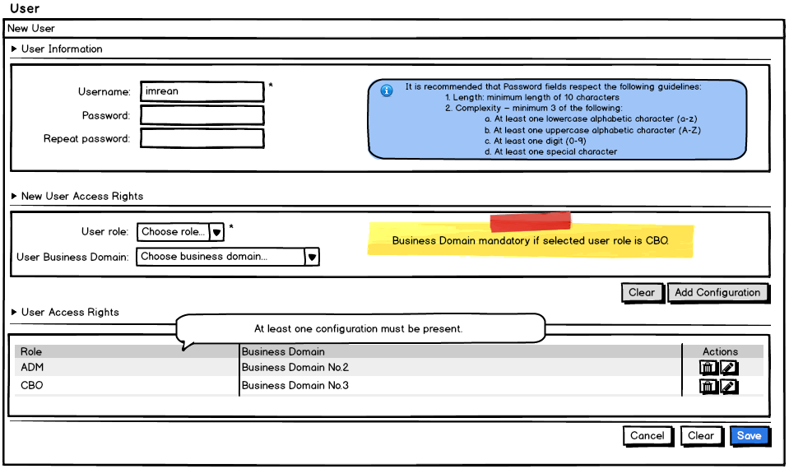
For users authenticated as CBO:
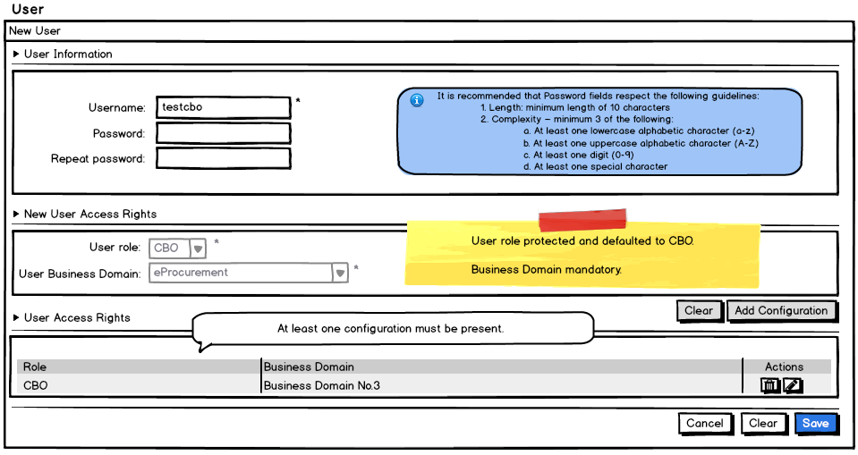

"Search User" page
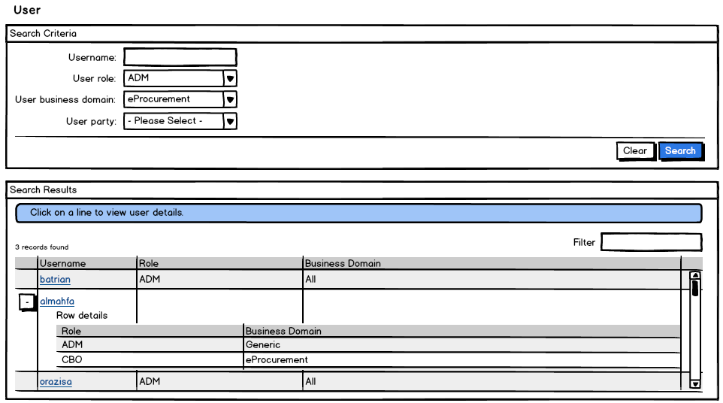

"View User Configuration" page
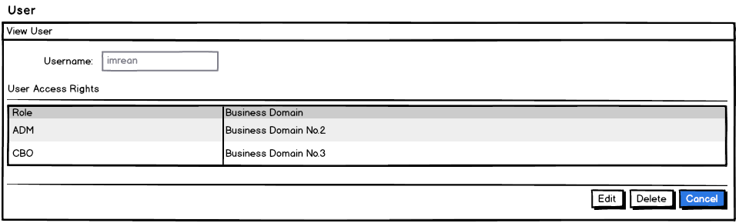

"Configure Existing User" page
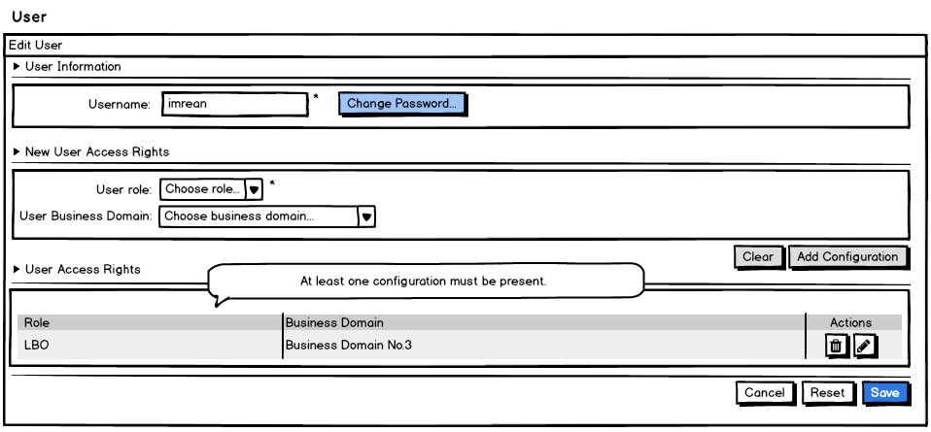

While editing, deleting existing user rights is possible ("partial deletion of user rights"):
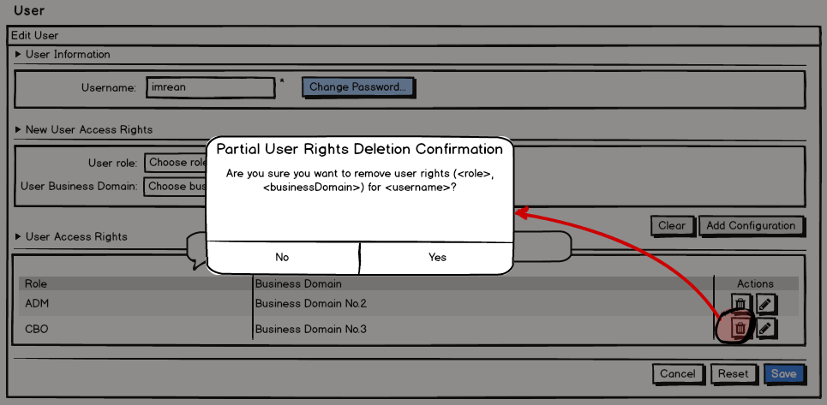

"Delete User" page
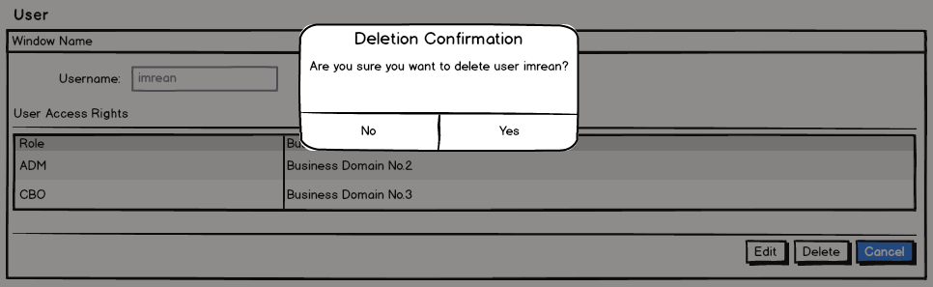

"Change Password" page
